7 Must-Have Tips Before You Get a Dog
These guidelines are suitable for Kids and Adults. Making your research easier
Helen Proudfoot | [Date] | CleopatraofthePaw.com

7 Must-Have Tips Before You Get a Dog

By Helen Proudfoot

Cleopatra of the Paw Edition | Copyright 2018 Helen Proudfoot

This eBook is licensed for your personal enjoyment only. This eBook may not be re-sold or given away to other people. If you would like to share this book with another person, please refer them to …………….
Thank you for respecting the hard work of this author.

https://cleopatraofthepaw.com/

https://cleopatraofthepaw.com/about-us

Hello Fellow Dog Lover,

Thank you for taking this step, so we can help you choose the right type of dog for your lifestyle and family.

My name is Helen, and my forever loving fur friend is Cleopatra. She is a six-year-old Shih Tzu. Our website is CleopatraofthePaw.com.

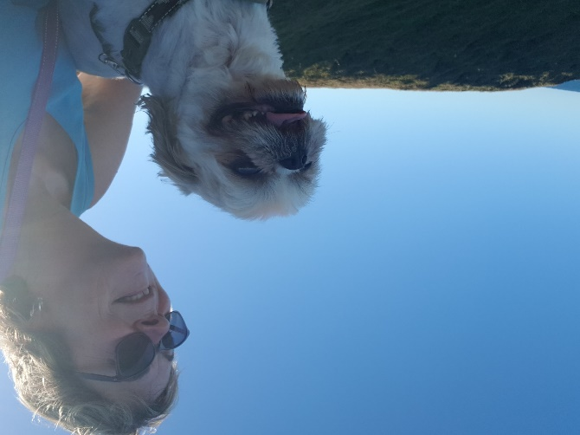

Having a pet has always been important to me, I never tire of that exciting, happy face and wagging tail when I wake up, come home from work, take her for a swim or even when I have come back inside from putting the rubbish out. They are so eager to please and forever faithful to us.

It can be confusing when deciding to get a puppy or a dog. All pets are great companions and a long-term commitment. Unfortunately there are some people who do not understand this or care and appreciate dogs as we do. With my knowledge and experience, I will provide you with information to make your research easier.

Where Not To Buy Your Puppy or Dog From

I care deeply about this topic. To help you not support puppy farms/puppy mill/puppy factory here is a couple of guidelines:

- it is vital to visit where the puppy/dog lives
- see the mother and father if possible to observe they are happy and healthy
- the mother and fathers personalities and traits
- their living conditions

Pet lovers and animal rights groups are opposed to Pet Shops due to:
- the sale of the animal is for profit
- it is perceived and often proven these animals are involved in the puppy farm industry

Visit your local animal rescue sites as there are always beautiful dogs and puppies looking for a home or find a responsible registered dog breeder.

Join my Facebook group …………………. and join fellow Dog Lovers. Ask questions and share your fun-filled adventures with us.

Let's get to the Tips.

Owning a pet is an integral part of our family. It is gratifying and long-term responsibility. Your commitment includes providing for all their requirements – a home, food, exercise, grooming, training, love, time and veterinary care.

Researching the essential basics, you will need to provide is vital. We all have pets for different reasons however the same primary pet care is a requisite for them all.

Far too often we see pets surrendered to pet shelters or even just left to their own devices. They do grow up to be adults and like humans, if they are not taught and trained, socialised, exercised and fed correctly it can cause behavioural and health problems, in turn, creating unnecessary and inconvenient costs.

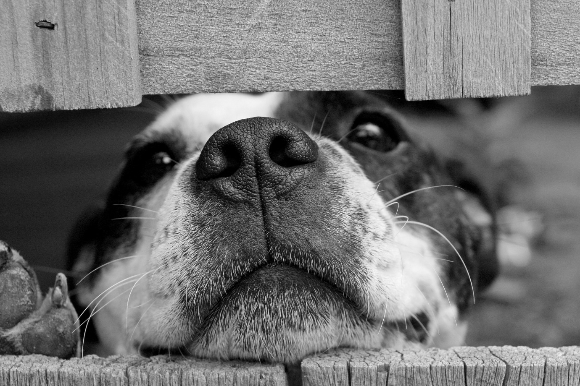

The Dogs Purpose

There are different reasons why people decide to get a dog. The following are possible factors:

- Dogs are great companions. They are always willing to please and want to spend time with their owners.
- Dogs are great for security. For families and singles, dogs help minimise the intrusion of unwanted break-ins and robberies.
- Studies have shown dogs to be of great help with children and adults who are going thru a traumatic health problem or a born with health issues.
- Parents often pair an appropriate dog to their children to help learn responsibilities and to learn life skill when they pass away. Sadly none of us likes or deals with it very well however it is a crucial part of our life experiences.

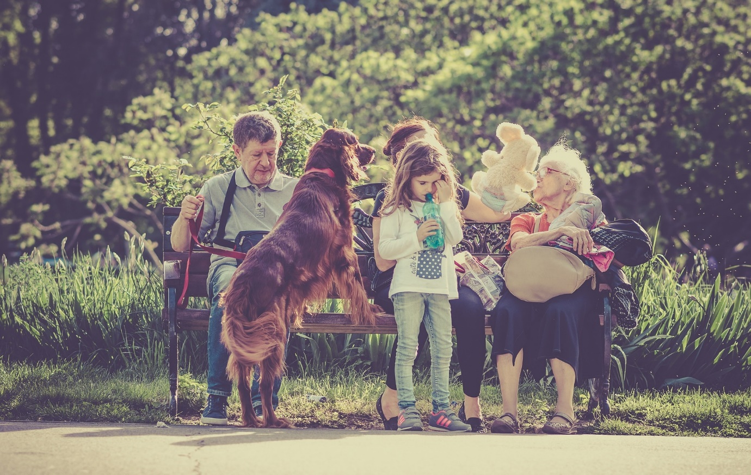

Puppy or a Dog?

For some getting a puppy and starting from scratch is their preference. You train the puppy for the lifestyle you have, and your dog will grow with you.

Other people like to have a mature dog that is over the puppy stage of those sharp milk teeth, the digging up of the yard, the chewing and not having the time to train them.

Whichever you choose they still require the same loving care (which you get back tenfold)

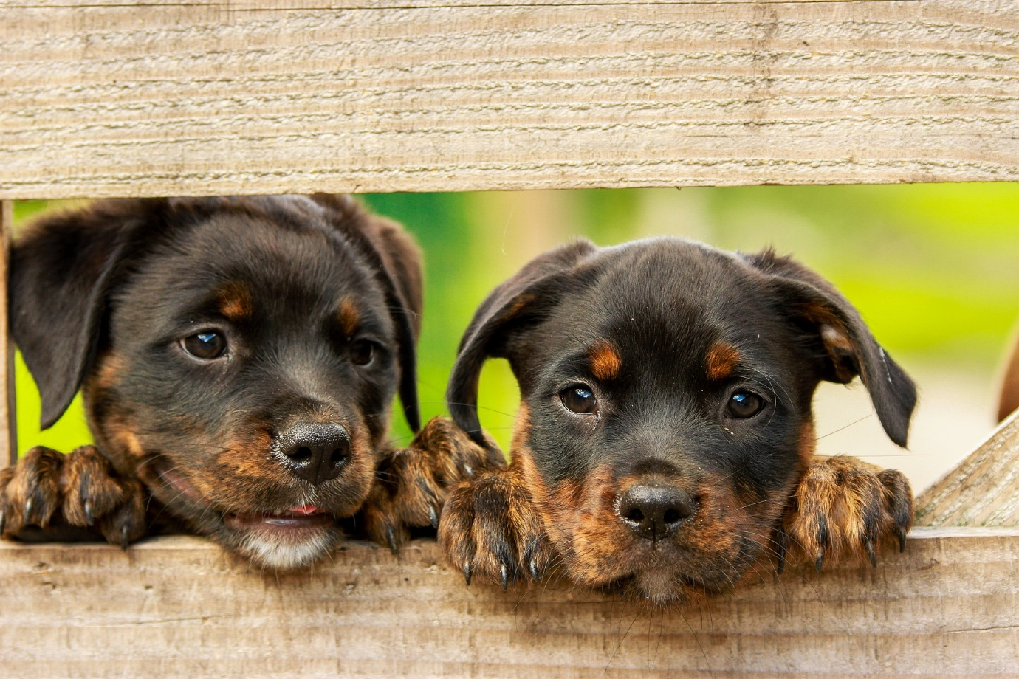

A Male or Female Dog, Which Is Best?

There are a lot of questions to answer before getting a dog, like a small or big dog? Female or male dog? But what is the difference between male and female dogs? Some dog owners claim that male dogs tend to be more aggressive and destructive, especially in small spaces, while female dogs are said to be easier to train and more affectionate.

Depending on the type of dog, these stereotypes may be right. Getting a female dog means either deciding to spay or deal with the problem of a dog that is in heat.

The female dogs do not have menopause so they can have puppies all their life. You will spend weeks every year trying to protect your female dog from the male who may catch the scent from blocks away. You will also be continually trying to find a home for your adorable litters of puppies. On the other hand, if you have a purebred dog that you want to raise, then having a female dog can become a financial advantage.
\
A male dog tends to be more affectionate, demanding and focused on their owners compared to the bitches. Female dogs are more inconsistent and independent of their human owners. Female dogs are adorable, but they like to go on their own, male dogs need more attention and pampering.

In relating to children, almost all dogs are a child-loving companion. Some believe that female dogs are better than male dogs because they naturally care for and protect their young ones, even if they are of another breed. On the other hand, male dogs only see children as their playmates and can sometimes get frisky. But both female and male have affectionate emotion towards children. They have a strong sense of security for little ones.

Its believed female dogs are easy to train; this is because they are less distracted. The Male dogs are playful, goofy and it is challenging to make them concentrate on a particular thing. Do not forget that in the competitive dog world, male dogs are usually more dominant. It is possible that male dogs are more ready to please their handler.

Since there is no evidence to predict the characteristics of female dogs compared to male dogs, the battle dog gender is a personal choice. The chances are that your memories of a childhood dog or a friend’s dog that you wish you had are what help you choose.

Finally, when considering behavioural differences, a dogs behaviour depends mainly on their training and how the dog is raised and their environment. It is a fact that female dogs do mature earlier than male dogs making this a plus when it comes to training.

Different types of Dogs breed

Purebred dogs are those that have a long ancestral history and have no mix in their past. They are not allowed to mate with dogs of other lines of a lineage that would give out another range of breed. The hybrid variety, as its name indicates, is the one that at a given time mated with dogs of other races and create a new breed.

Maybe you are a dog lover, or you are looking for a pet dog but cannot decide which breed to get. Whatever your reasons for considering different breeds of dogs are, you have come to the right place to start. When choosing a dog, owners usually look at different kinds of dogs to decide what they think will fit their lifestyle.

There are different types of dog breeds. They are classified mainly by the work they do or the behaviour pattern display. Here are some of the particular kinds of dogs.

- Hunting dogs: These are dogs that help humans to hunt and perform specific tasks like getting the birds from the water.

- Working dogs: These are the type of dog that can be a pet and also be trained to work on farms, security, Defence force and as Police dogs.

- Companion Family Dogs: These types of dogs usually do not perform any particular work, they are there entirely to be with their owner. A lot of different dogs breed are used merely for the joy of their company, and not as a working dog.

- Companion Therapy Dogs: These are vital dogs who have had a lot of training to be Guide Dogs and or help people living with psychological or physical health challenges.

- Lapdogs: These are the type of dogs that are small enough that it can be held and lie comfortably on your lap. Mind you I have seen some significantly sized dogs who think of themselves to be a lapdog.

Why should you consider this list before choosing a new puppy or dog? Because getting a new dog is like adding a new member to your family. The type you get will be crucial to your daily routine, whether spending time training your dog or walking it.

Different pooches have different qualities. If you are having trouble deciding on the type of dog you want to get, do more research about the different breeds and their characteristics or traits. Remember, it is no good getting a high energy Jack Russell, perfect as a fitness dog, if you want a low energy lap dog.

Rescue or Pedigree?

If you are looking to breed your dog, then a pedigree would be your primary requisite. Breeding dogs is a rewarding career and a massive commitment that comes with additional expenses.

If seeking a pedigree even as a pet, research the breeds first: their personalities, potential health issues, and specific care needs. i.e., inappropriate to buy Mum a Great Dane as a companion dog. Some breeds may be more appropriate than others.

The most popular dog is the good old Bitsa. Your friend's dog has had puppies, rescue dogs or taking over someone else's dog that they can no longer have, e.g., elderly going into nursing homes.

Knowing the mix of breeds in your Bitsa will also help you with training and behavioural traits. For example, if there is part Jack Russell in your dog, you will know for sure this is going to be a very active dog as their origins are for fox hunting. They are lively, and excellent little workers and can be a handful to train. Hence it is imperative that time and commitment for these small Jackies is invested.

For dogs with origins unknown, you can arrange a DNA test from your vet. It can be viewed as expensive, but it can also give you more awareness into your pup and his/her personality traits and potential health issues.
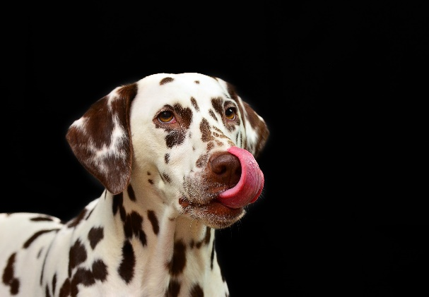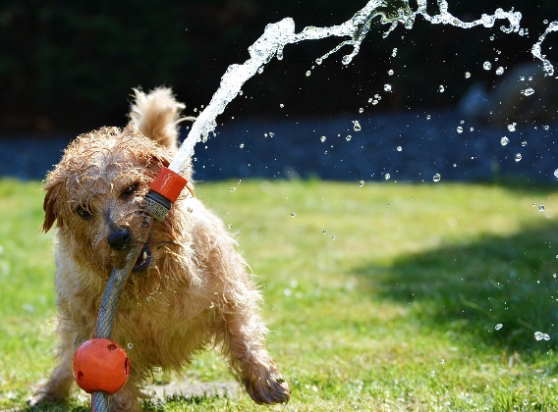

Inside or outside Dog?

When you get your dog, it is crucial to know what boundaries you will have set for your new companion.
Will they be allowed to eat and sleep inside or sit on your furniture? Or I will have an outside dog because we live and entertain mostly outside and have an excellent area for them to run and be free.
They could be a bit of both. Either way, setting the ground rules from the start is essential, and the dog will grow and learn their limits.

Shelter, weather, and toiletry requirements are also issues to be addressed. Do you need to have a doggie door installed or get a dog house?

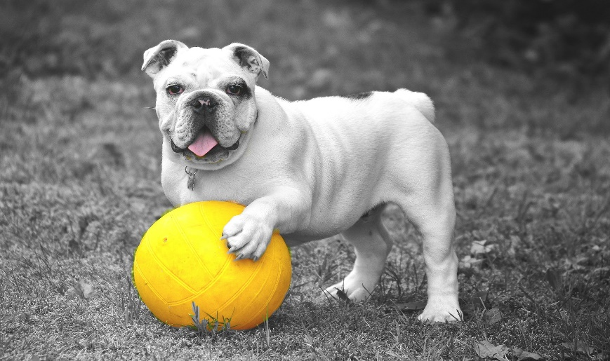

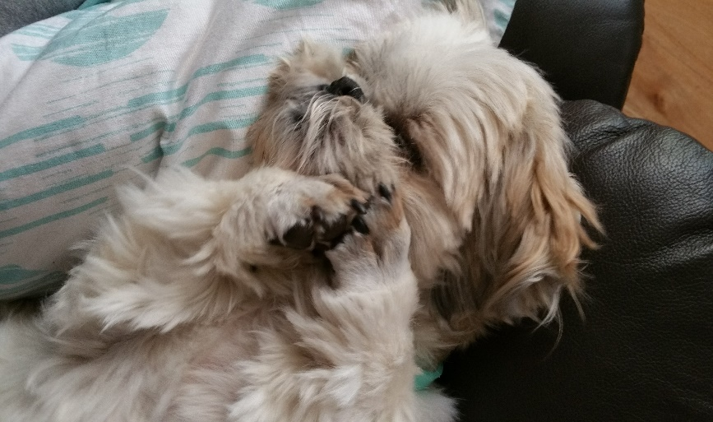

What size and grooming needs?

These are personal requirements:

- Don't care how big the dog is and they are purely inside dogs.
- Dogs that shed cannot come inside for health issues, e.g., asthma.
- Little dogs get under peoples feet.
- Do you want a dog you can jog with or happy for little walks and or a lap dog with lots of snuggling?

Assessing the size and what is the extent of the grooming requirements is paramount for when your dog grows up. Laundry tubs are perfect for little dogs. Oh, it is so easy on your back, warm water in winter for you and the dog. Larger dogs will need to be washed in a bath, in the yard or have a dog groomer visit regularly. Bathing is a requirement to consider. Come winter; nobody wants to have a bath in cold water including your dog; therefore, you may need to pay for the dog wash people to visit. I have experienced people not wanting to let their dogs inside as they smell, how confusing for them when they usually are allowed inside. This situation is an issue for all seasons. Lack of bathing can also lead to skin conditions resulting in more costs at the vet.
Cleopatra being a Shih Tzu has high grooming requirements. Regular brushing, clipping, cleaning of her eyes, etc. I knew this and taught myself how to clip her saving me $70 every three weeks. As I stay on top of these needs, they do not take too much time. Plus she does not shed which was why the additional grooming requirements did not concern me.
Grooming is so vital for your dog's health, some issues that arise from lack of grooming to be discussed in our next "Ensuring Your Home is Ready for a Dog.”

Now for the 2 Vital Tips, you may not have thought about in depth.

Can I commit?

The average lifespan of cats and dogs is 12 years, so this is a significant commitment with great rewards if you take the time from the start.

Your commitments also include:

- The possible expenses that occur and are required
- If you work long hours, you may need the services of a doggy day-care
- Do you travel for work for extended periods of time? Boarding expenses or rehousing with friends will need to be arranged. If this is your current situation, maybe consider delaying getting a dog as this is disruptive and can also mentally affect your dog as they do fret.
- When you go on holidays, can you take your dog with, if not the boarding cost is involved
- Feeding. Will you use dog food or prepare fresh meals
- Exercising and training. Do you have the time? Dog walks are a daily, if not twice a day requirement

Not a nice quote, however, it is true - a bored dog becomes a problem dog

Vet expense / Pet Insurance

Here are the expenses for owning a pet, which is also a lifelong commitment.

- Straight up the cost of buying your pet
- Vaccinations, microchipping and desexing
- Worming and annual vet checks
- Tick and flea treatments
- Food
- Training
- Grooming, e.g., shampoo, nail clippers
- Toys and bedding
- Boarding expenses when going on holidays
- An emergency requiring veterinarian treatment

Depending on the type of dog you choose the costs will vary. Larger dogs = more food, bigger beds. Due to the dog's weight, worming, tick, and vaccinations are more expensive. Pets are an additional expense, and I am okay with this due to the pleasure and companionship I get. I did thoroughly research all of the above based the type of dog I was getting.

Pet insurance is a personal decision. If you are good with your budget and can put $$ aside for annual treatments and to help with an emergency, this is great. Another aspect is to look at the particular breeds health needs, e.g., hip dysplasia, possible eye problems with say a Pug or Shih Tzu. My decision to have health insurance was also to do with the paralysis tick. These ticks are in the area I live in, oh so are snakes and spiders. The treatment is costly and must be acted on ASAP.

Do Not Rush

If you still have not decided on your type of dog, do not rush, this is a lifelong commitment, and you both want to be happy. You are going to make an excellent Dog Parent once you have completed your research and found the Dog that suits you or your family.

I look forward to providing you with more helpful information in "Ensuring Your Home is Ready for a Dog" that will include:

- When you bring them home
- Toilet training
- Whether to desex or not
- The importance of socialising and training
- I cannot wait to share with you how your dog learns and their body language

We wish you have as much fun and share the love as Cleopatra and I do.

WOL = Wag out Loud, everywhere you go.

Helen and Cleopatra

P.S. Tell us about your new member of the family oh and please show us a picture.

Where you can find us:
Cleopatraofthepaw.com
instagram.com/cleopatraofthepaw/
facebook.com/CleopatraofthePaw/ maybe changed to a FB group

I just love this

